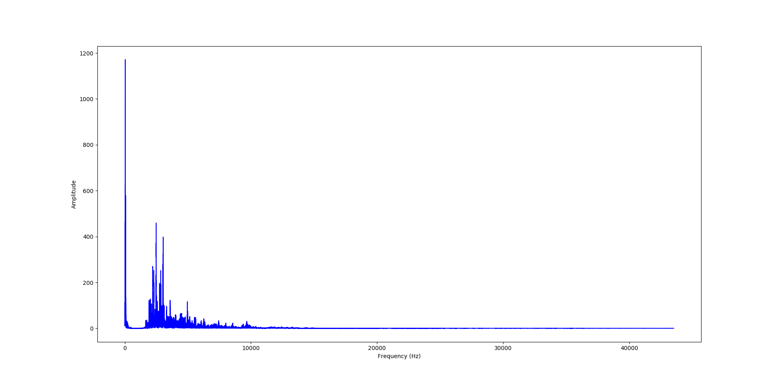

Fft analyzer : x=459.09845 , y=1086

* 1171.7605 , 38